**Metasploit TryHackMe**

Task 5:

The database we set up in task-2, will be used to scan. Metasploit already have some modules which serves the functionalities of nmap and netcat. So we don’t really need the nmap.

Run **db_nmap -sV <ip addr>**

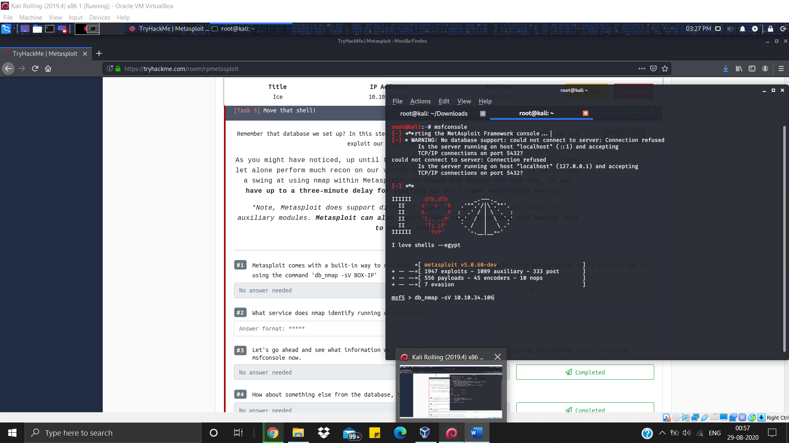

Scan will give results like this

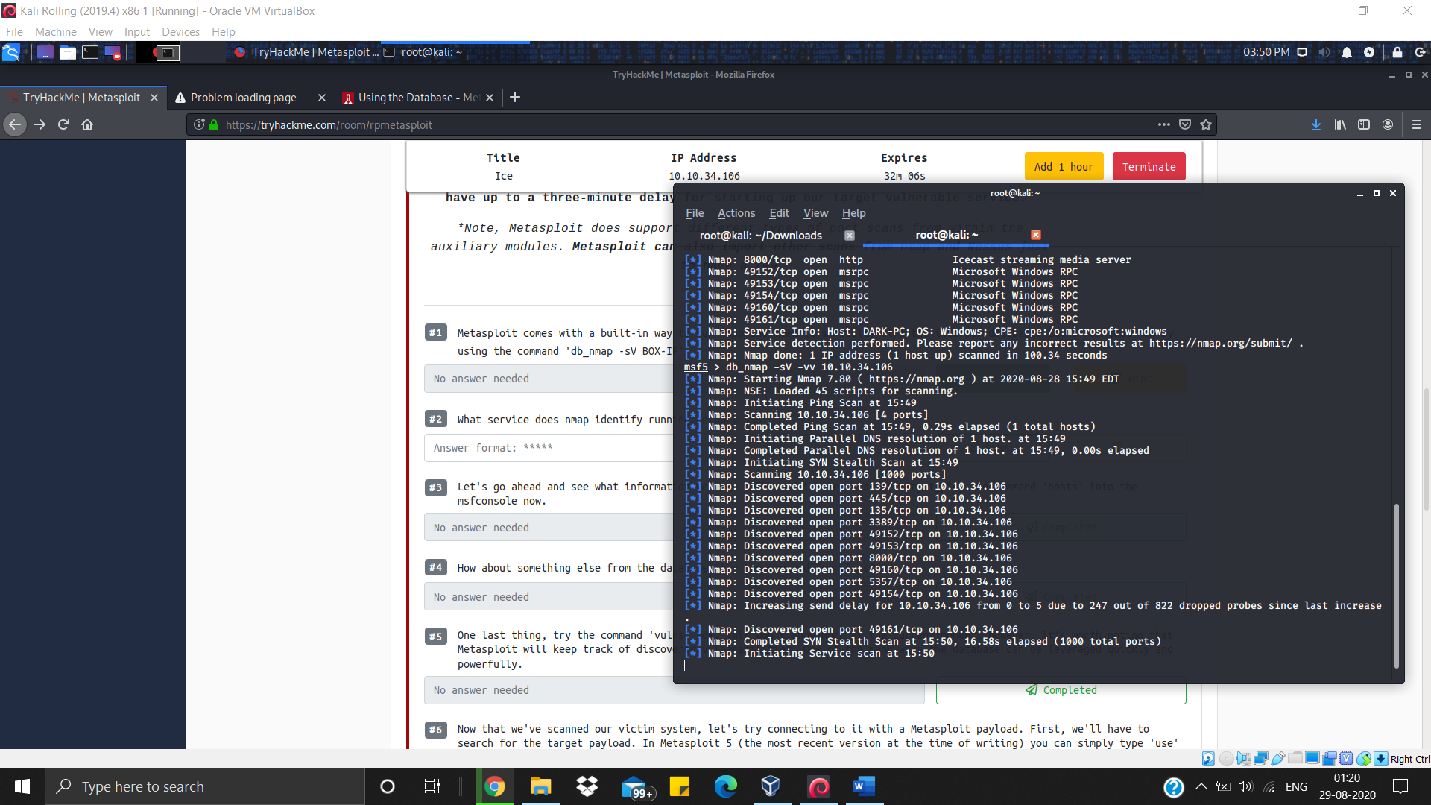

To get deeper into this and to look that what data we have collected run command **hosts** inside msfconsole.

And we got this

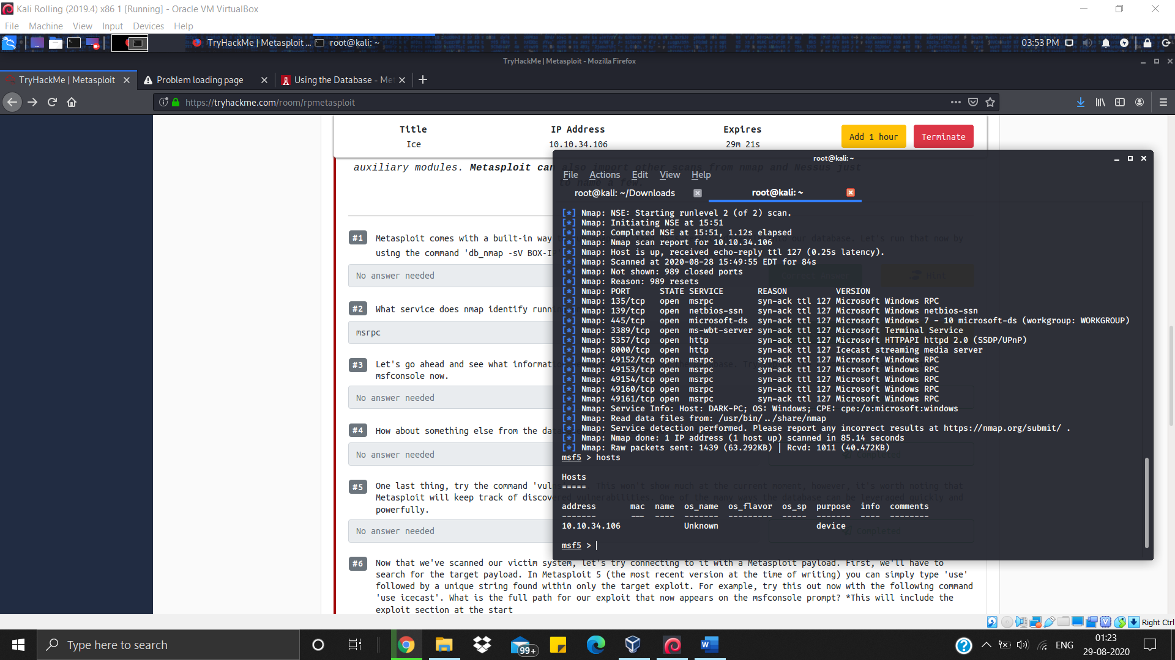

Next we are asked to run command **services**, and we got this result

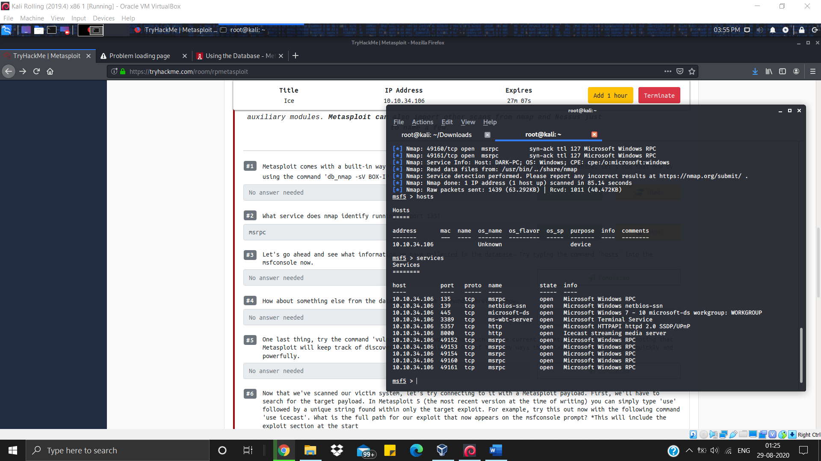

Then it asked for running the command **vulns**, which will result this

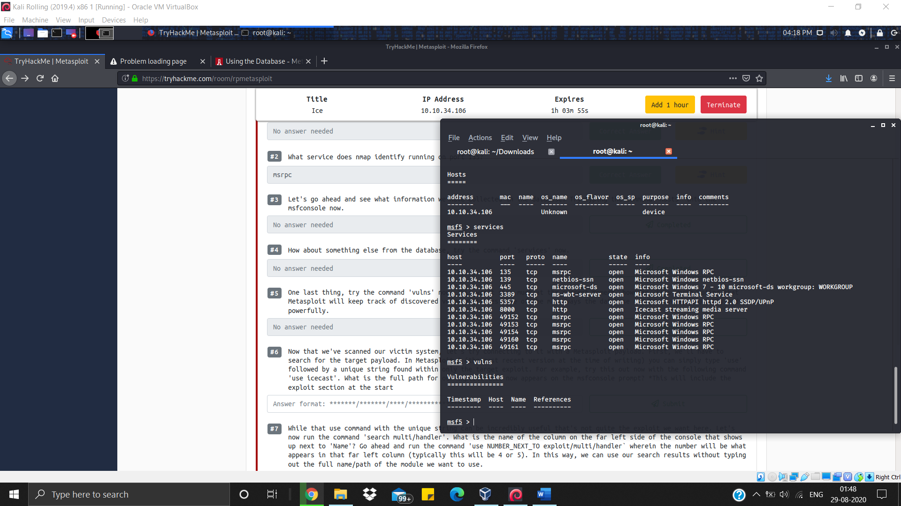

The clue was given in the question that run command **use icecast** to use payload icecast

And we will get the required string

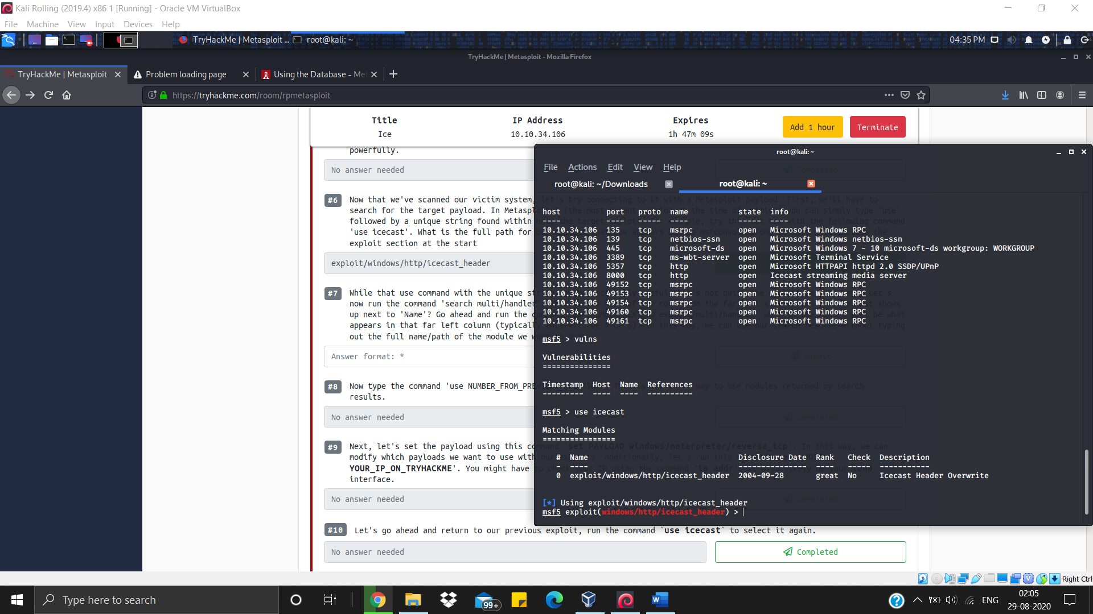

In the next statement we are asked to run command service multi/handler

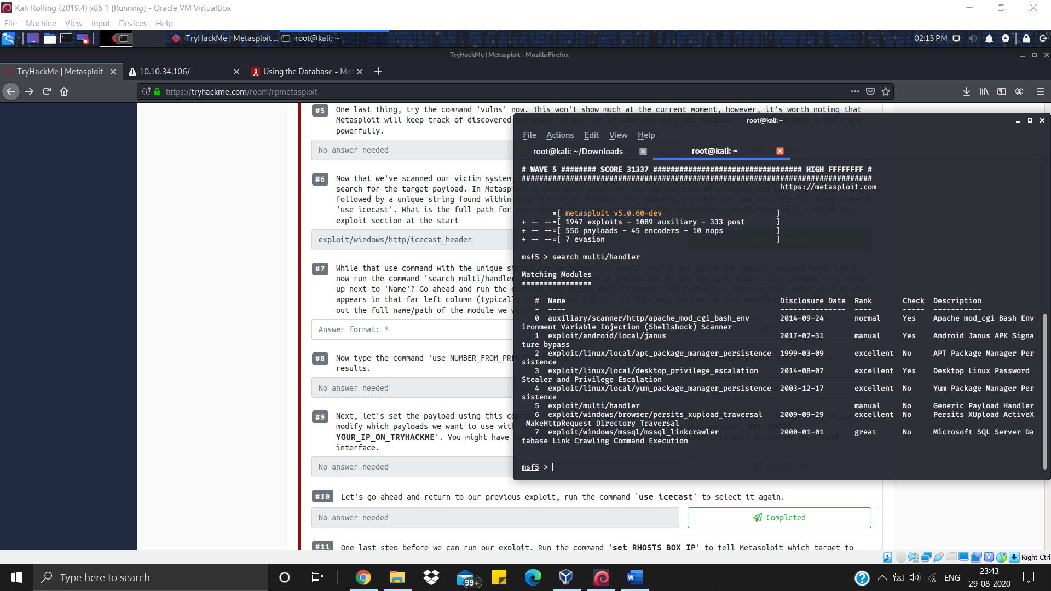

Next command is use NUMBER_NEXT_TO exploit/multi/handler to run

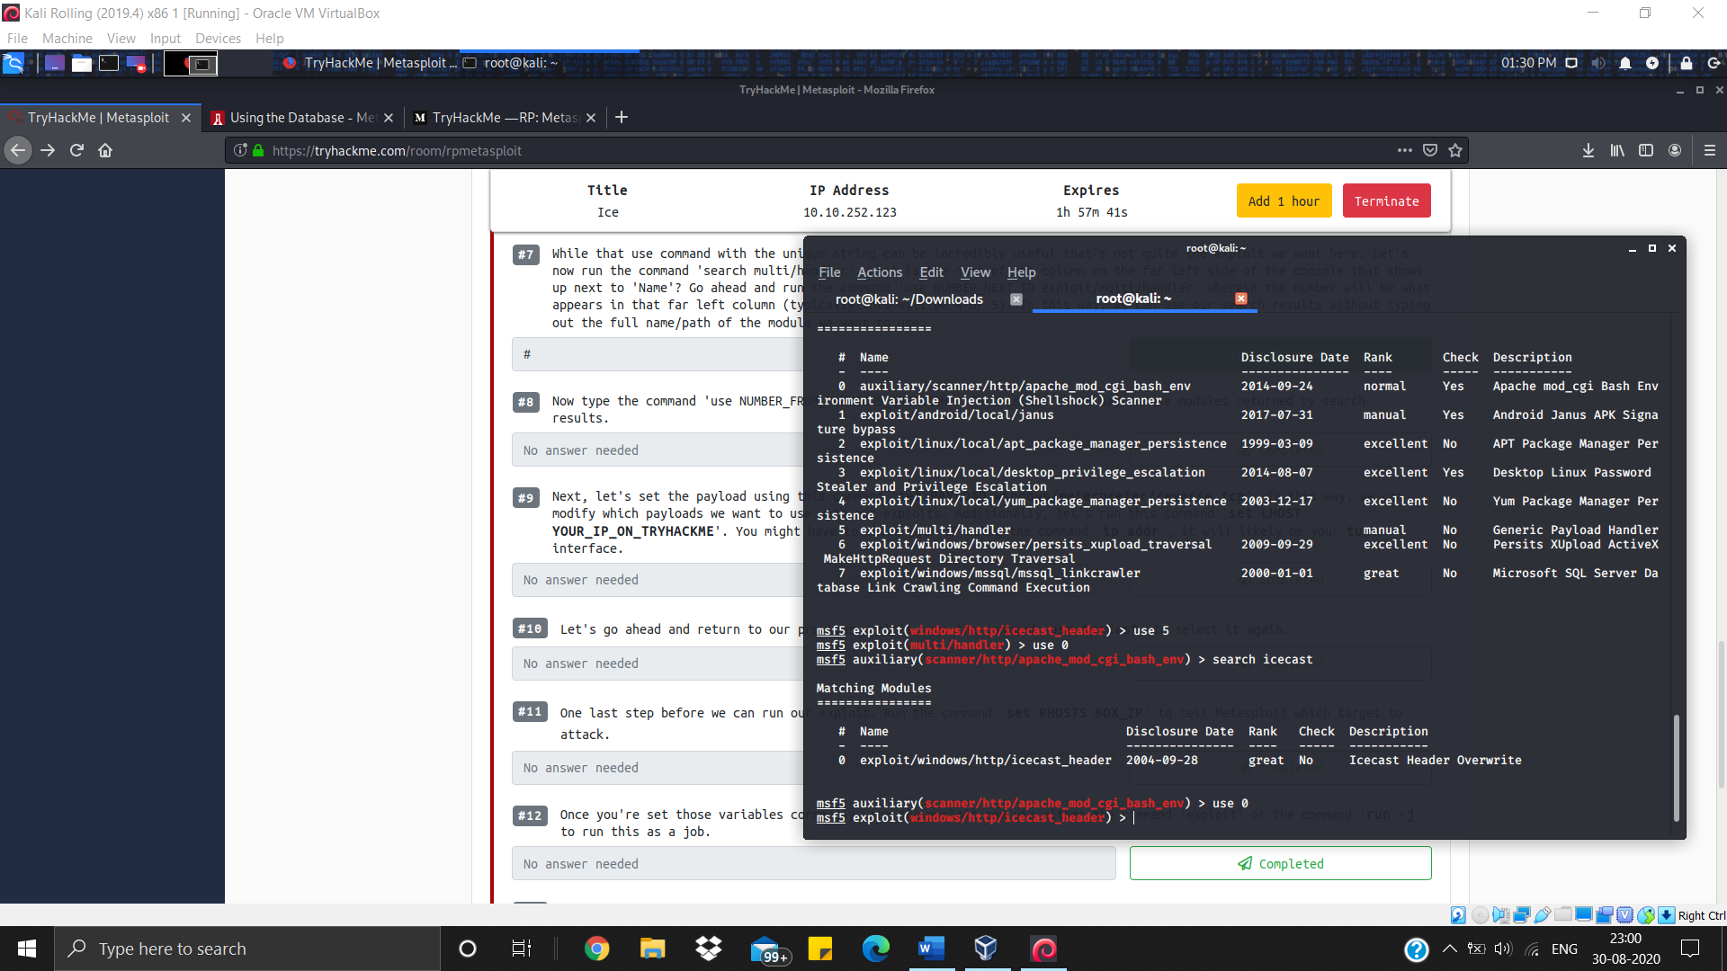

Next task is to set the payload which will be done using the command set

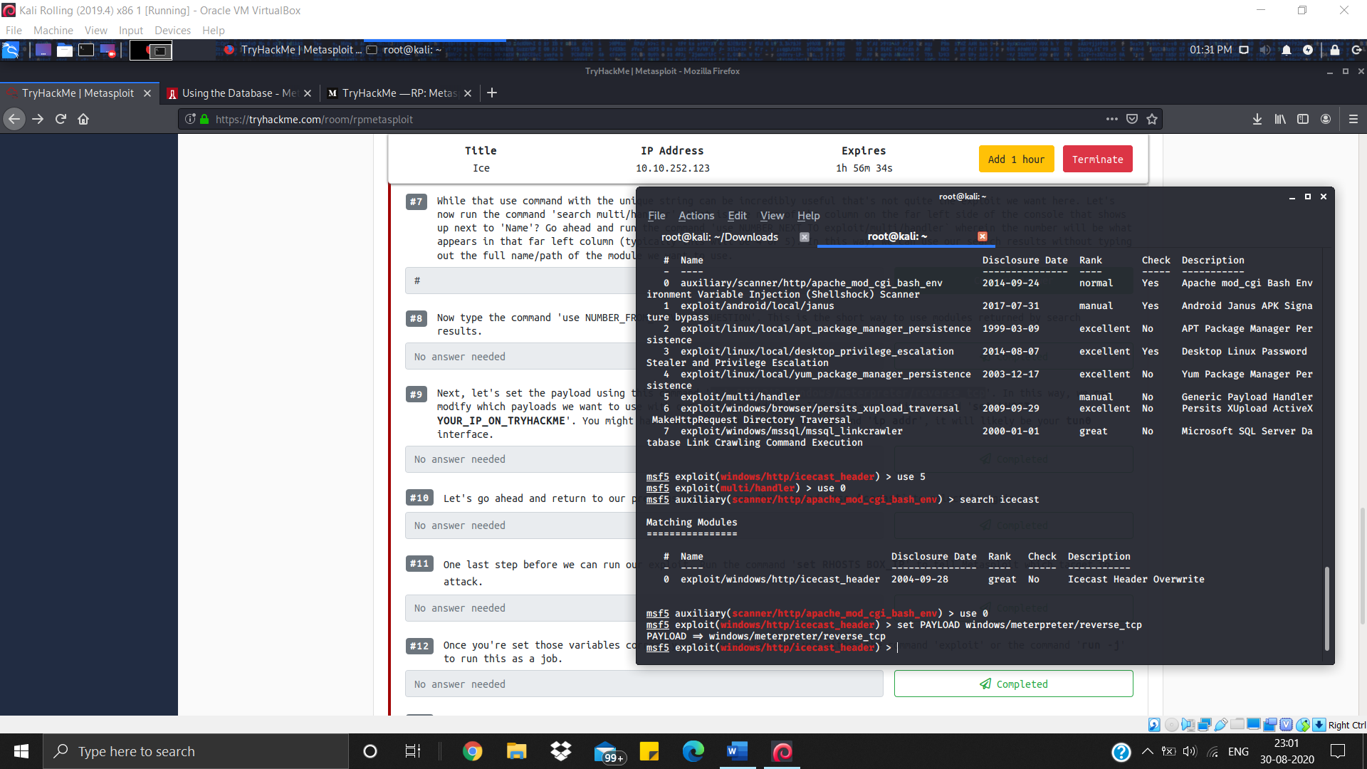

Now, let’s set the LHOST

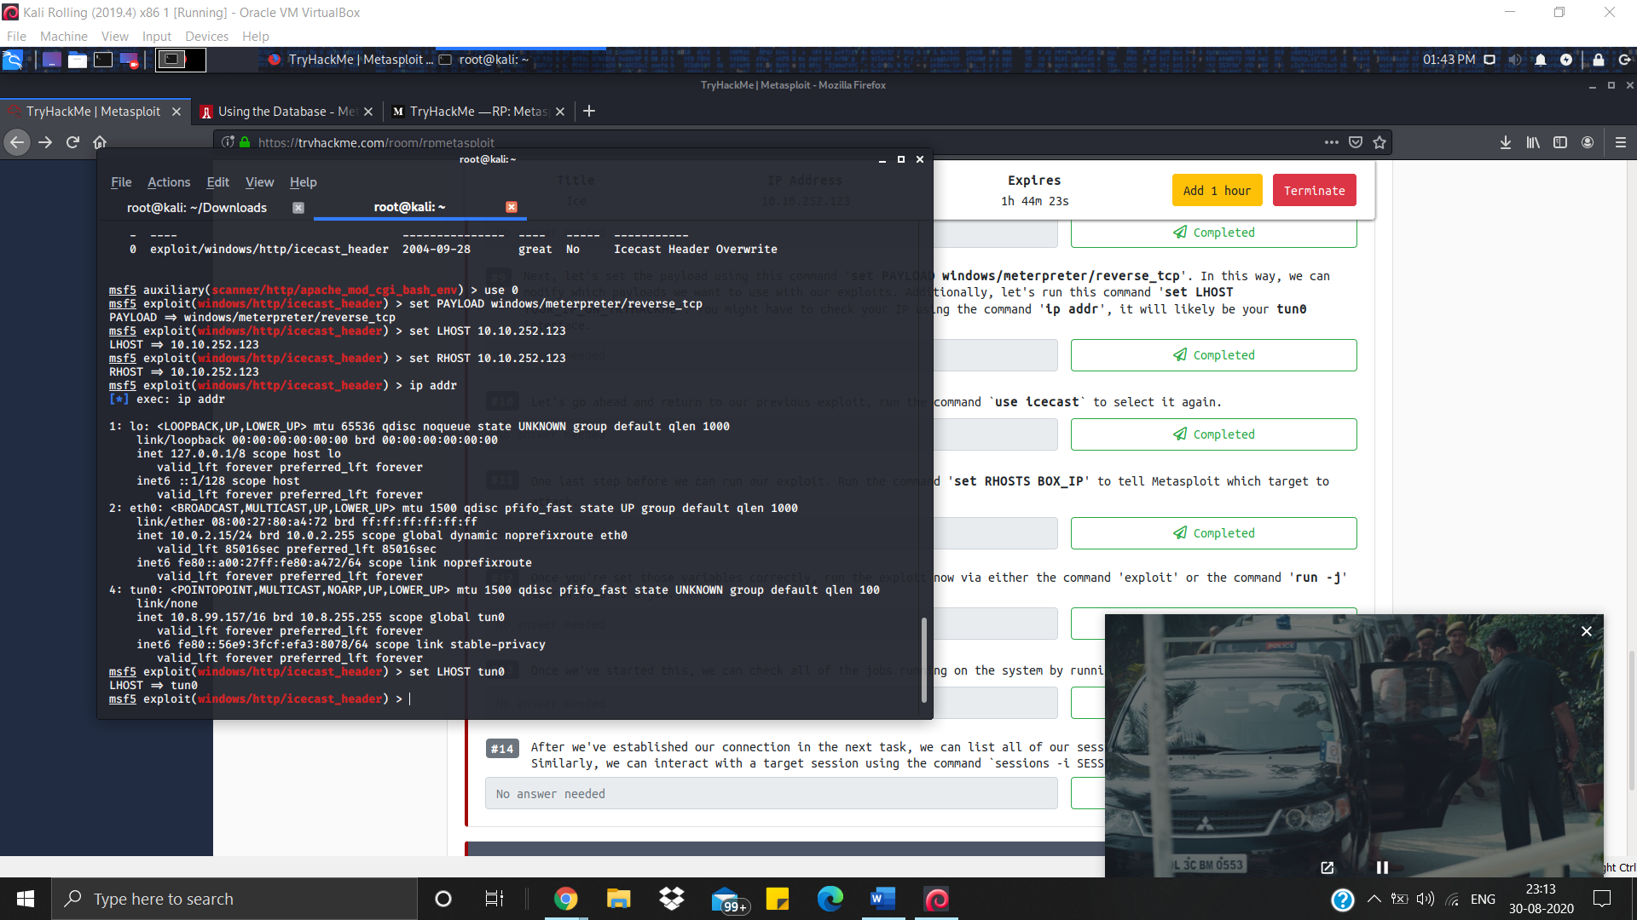

Set RHOST too

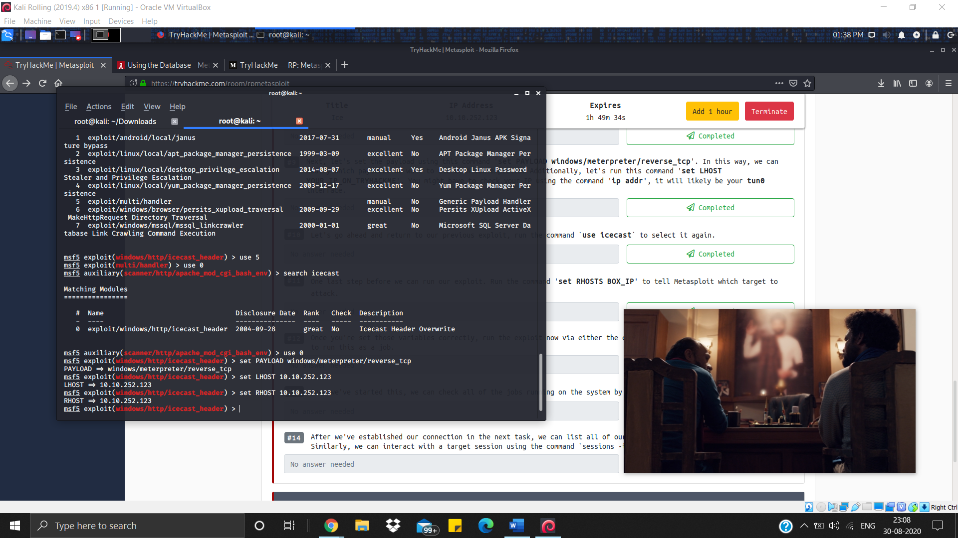

All set. Now we are ready to run exploit by using command exploit

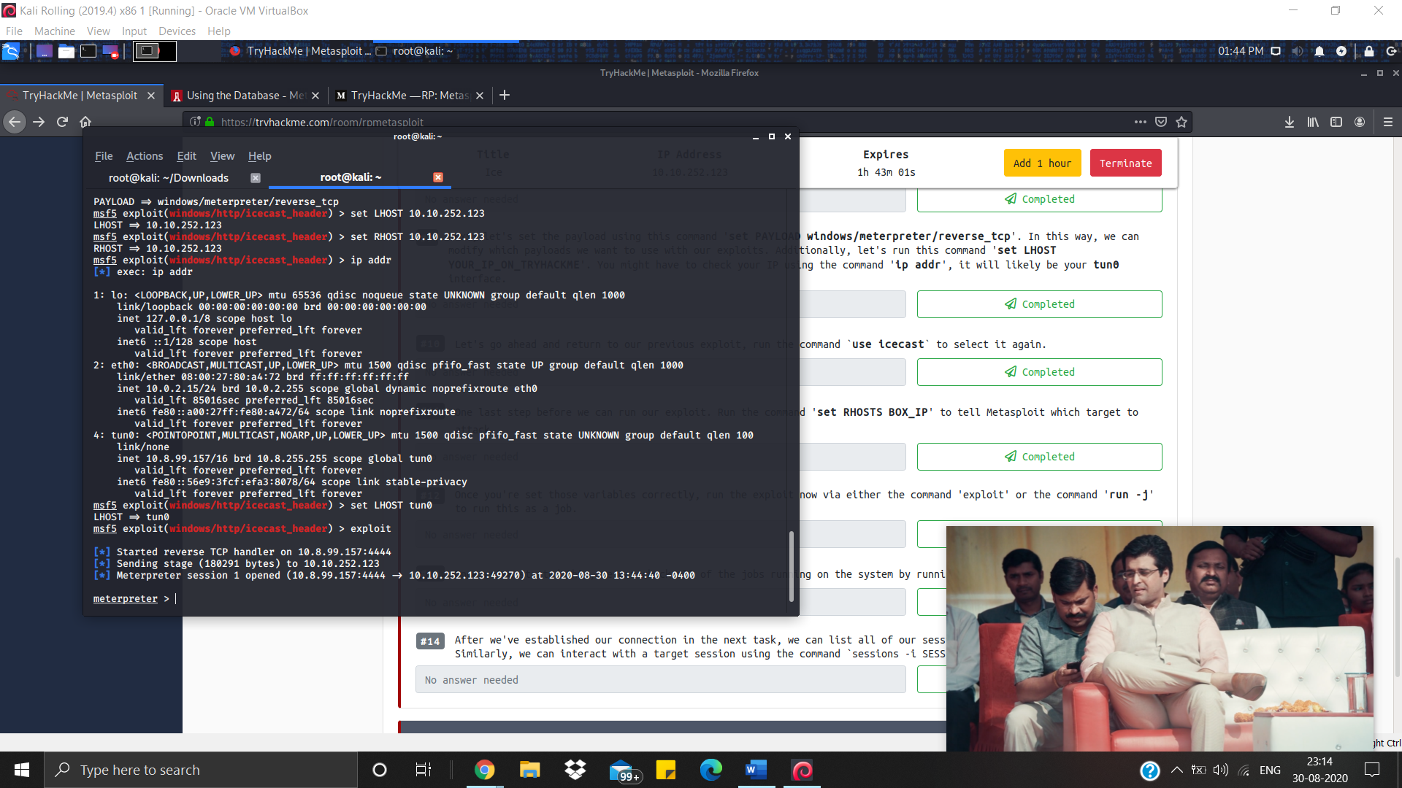

To view running jobs, run command jobs

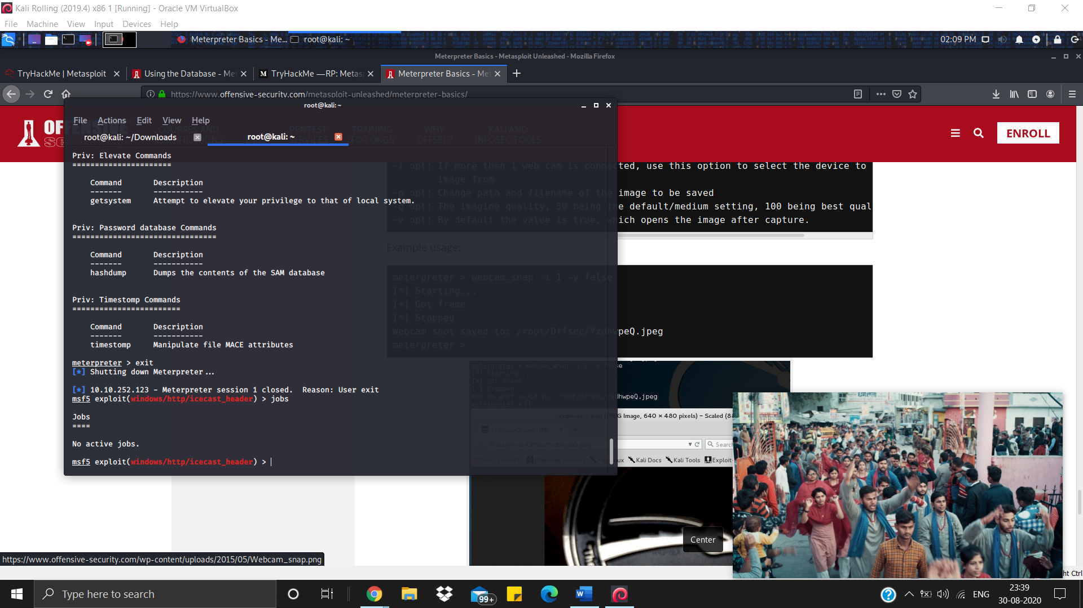

To list all the sessions running, run command sessions

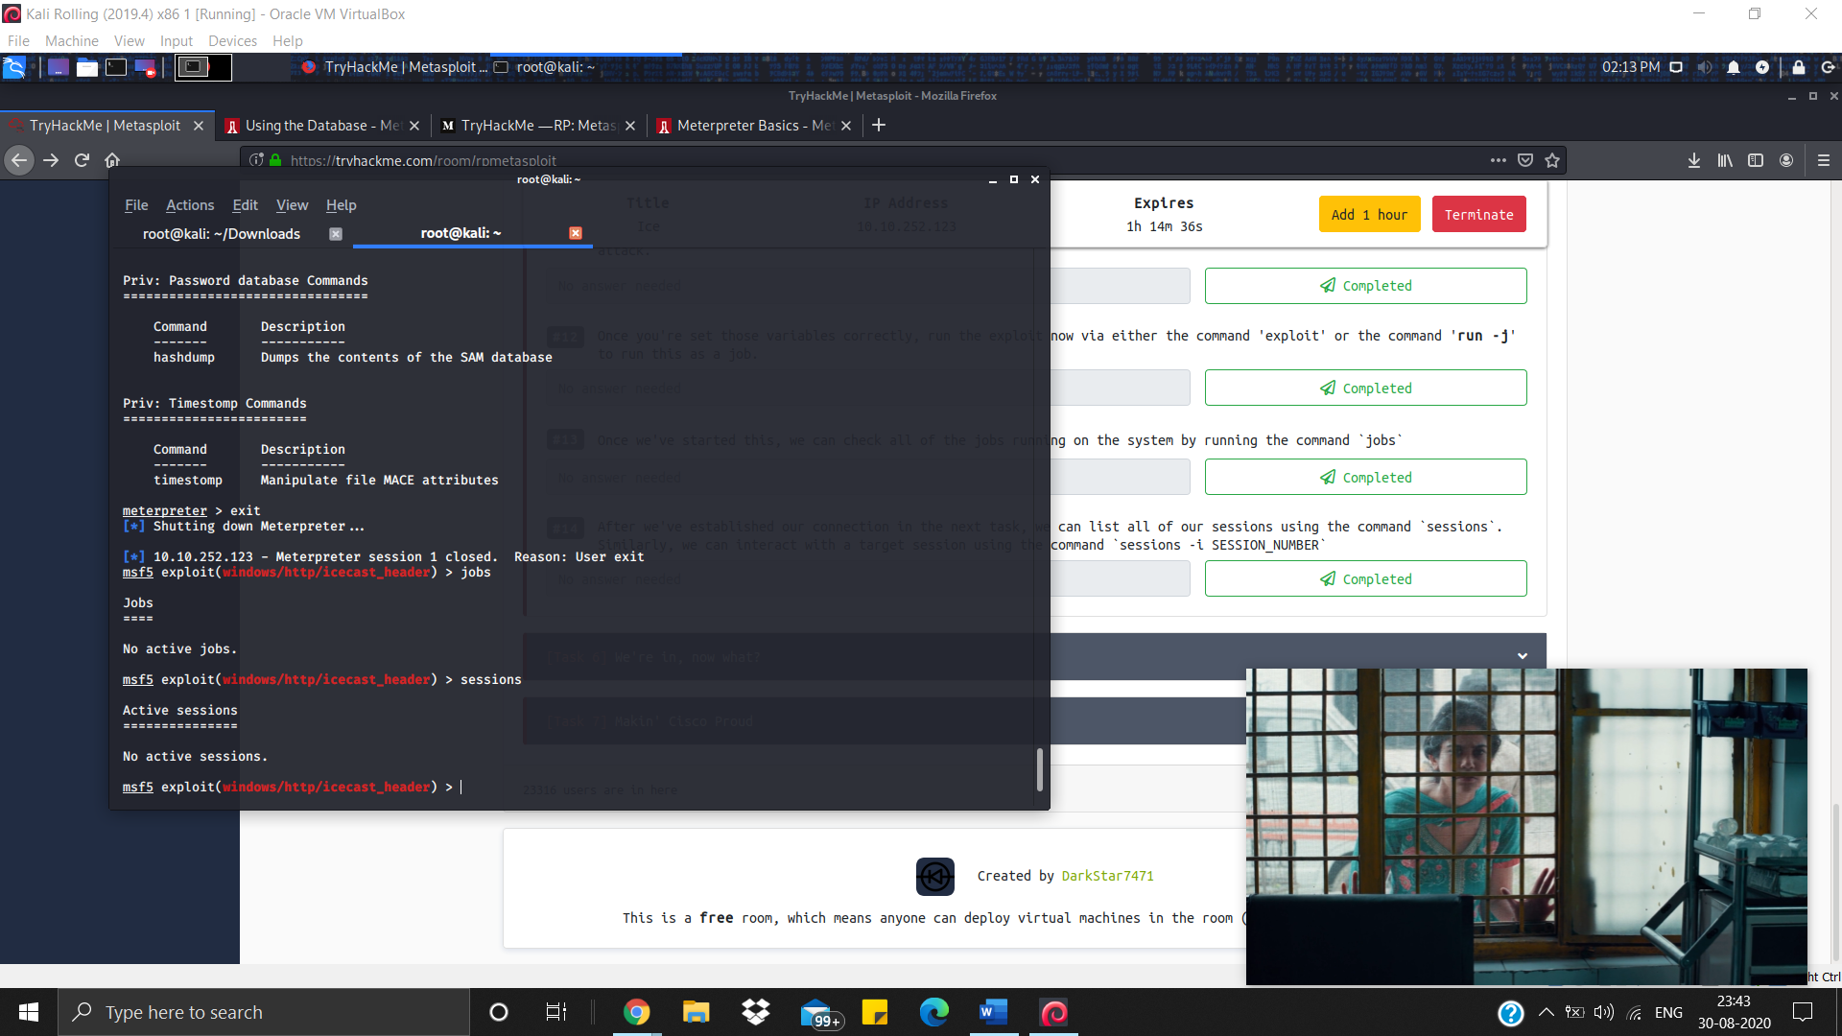

Task-6

To list the processes running run ps command

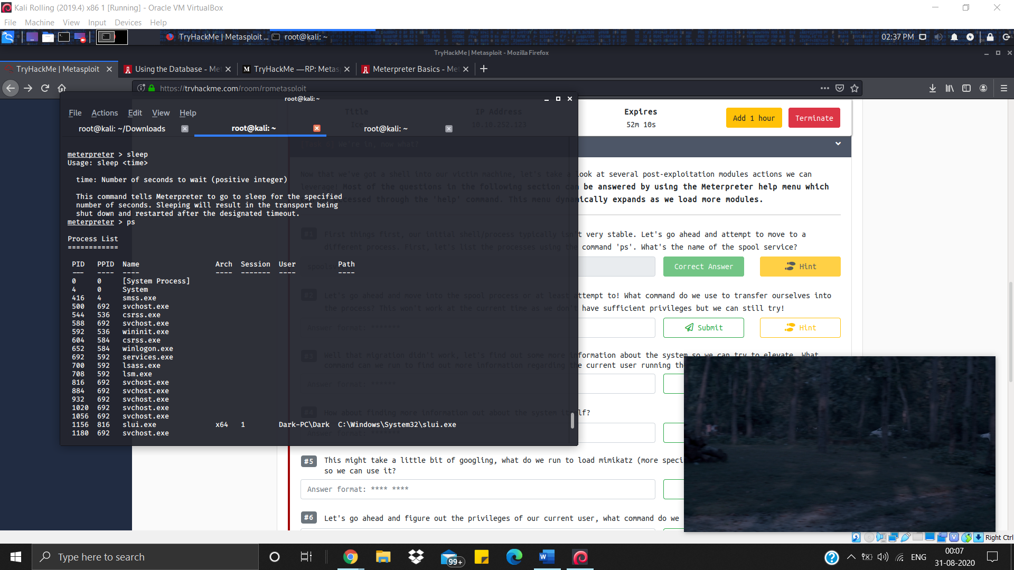

Migrate is used to get into the process

But it won’t work

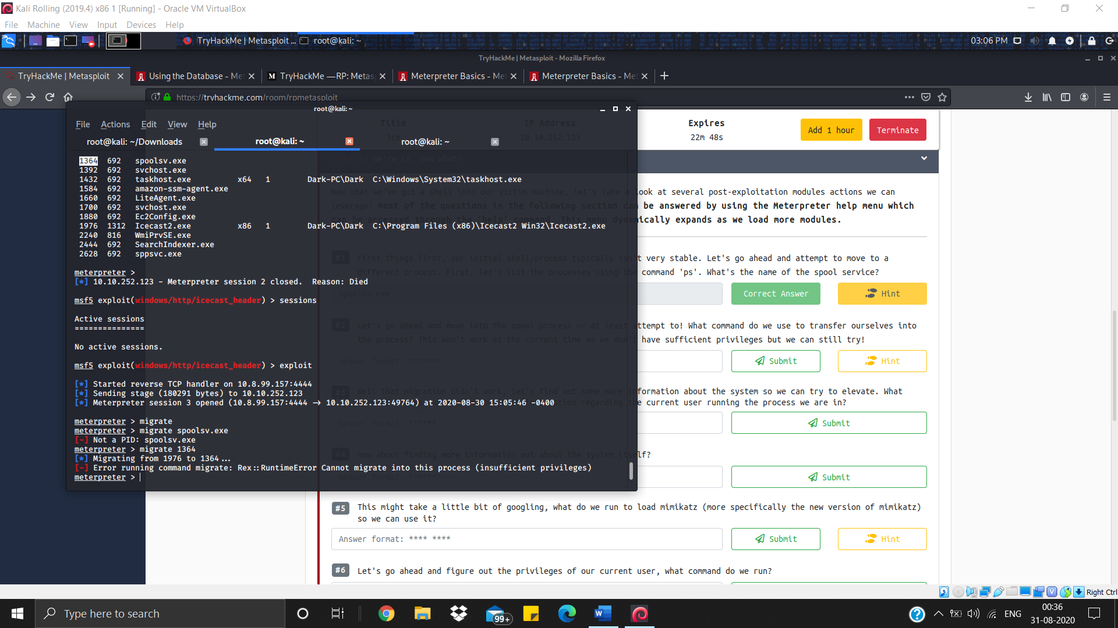

In help section, we find the answer to the question that how can we get the user who is running the process we are currently in.

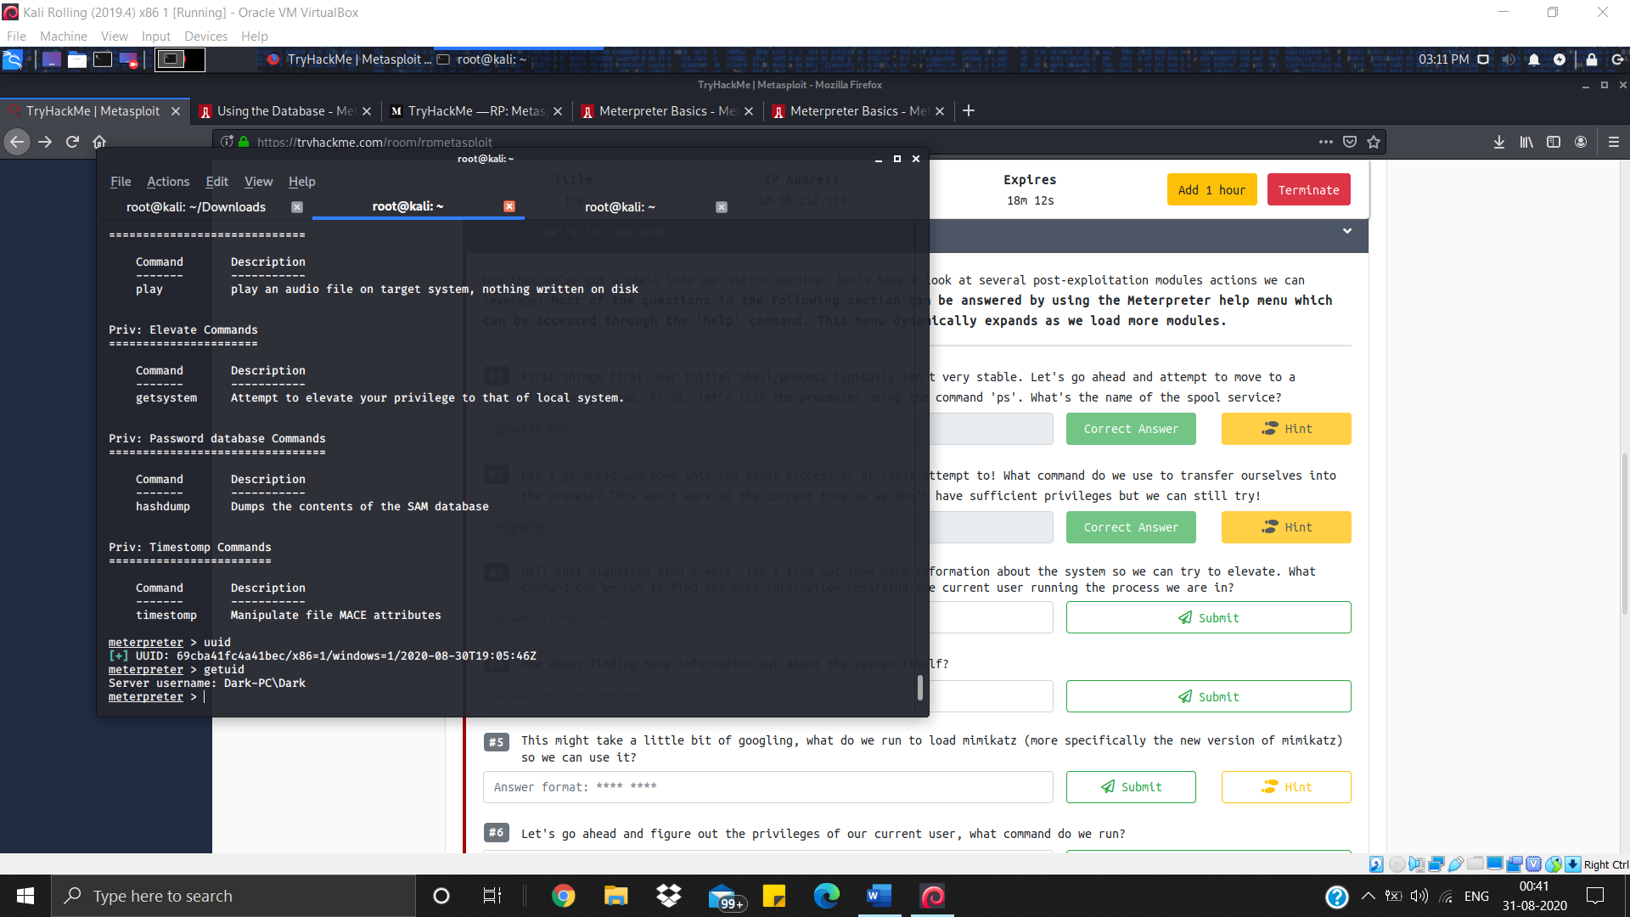

Sysinfo is the command used to get to know more about system itself.

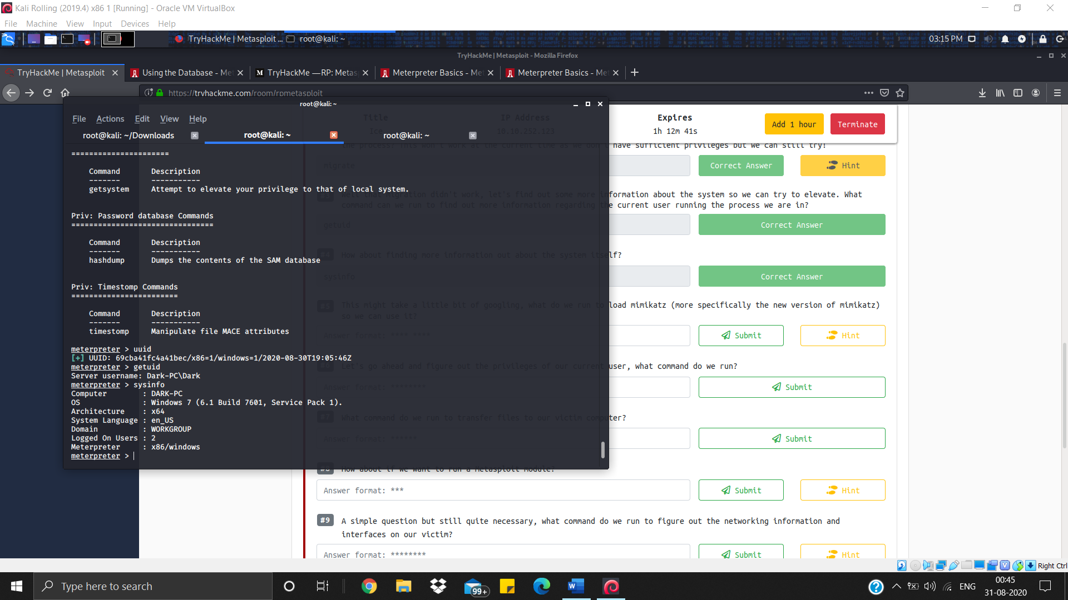

As **load** command is used to Load one or more meterpreter extensions so it can be used to update kiwi/mimikatz

Getprivs is used to Attempt to enable all privileges available to the current process

And upload is used to transferor upload the files or directory

If want to run a Metasploit module type run

Ipconfig or ifconfig both command can be used to figure out the networking information and interfaces on our victim

To check if we are in a VMrun command run post/windows/gather/checkvm

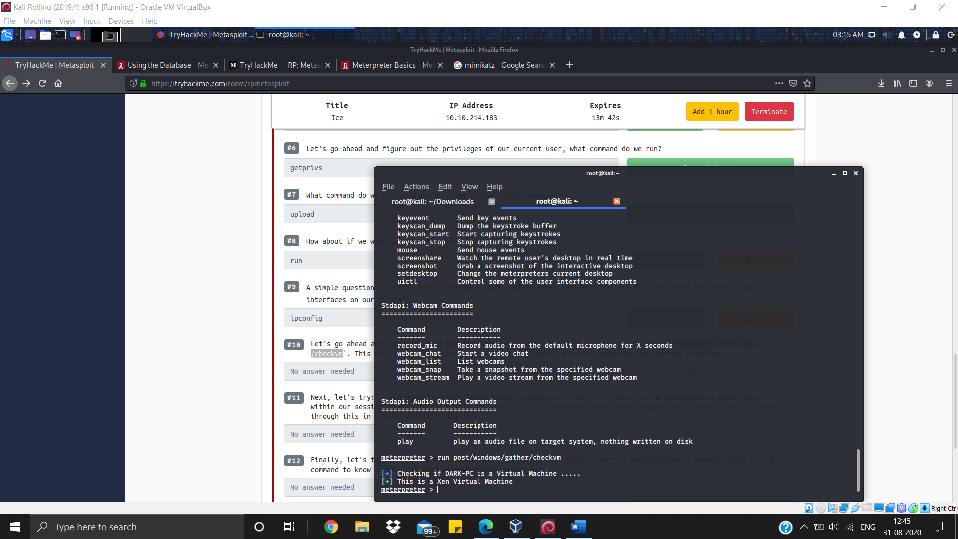

run post/multi/recon/local_exploit_suggester in meterpreter only

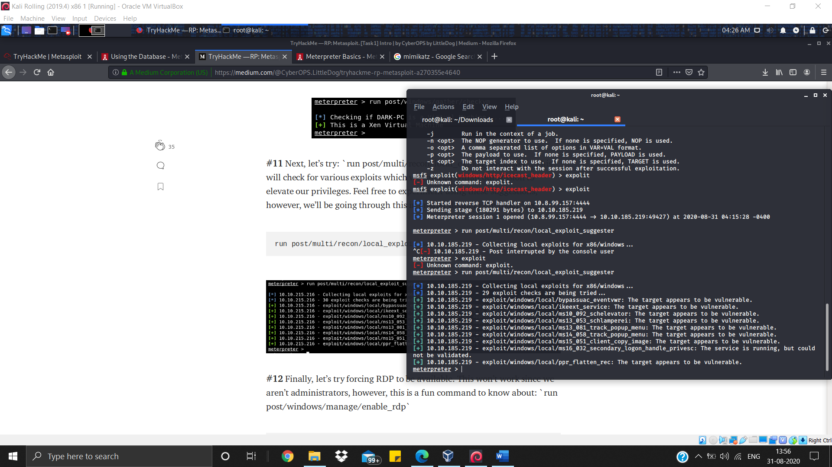

run post/windows/manage/enable_rdp

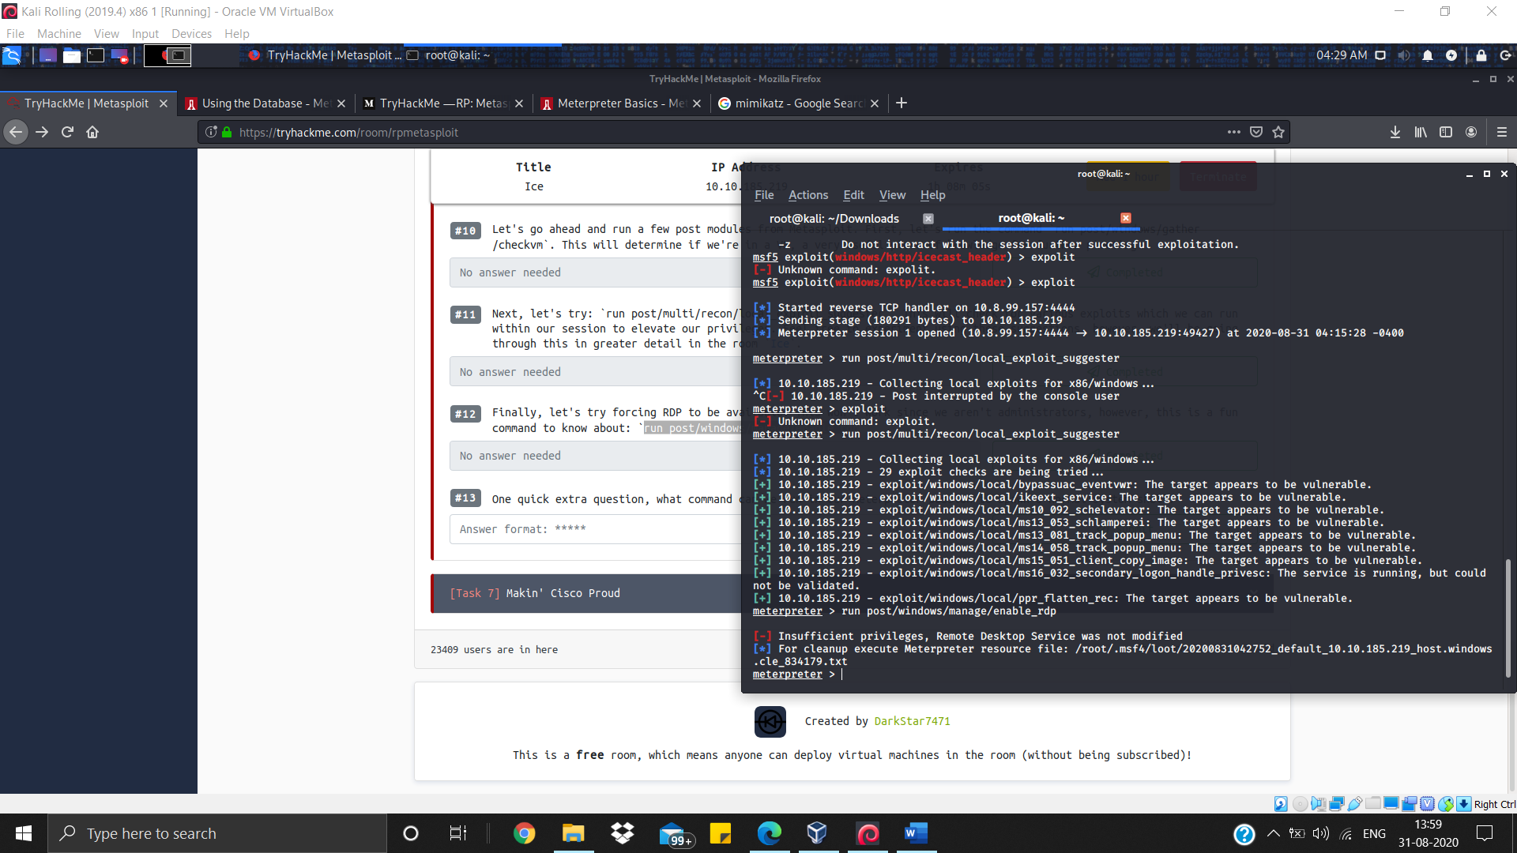

Run autoroute -h to open help menu of autoroute

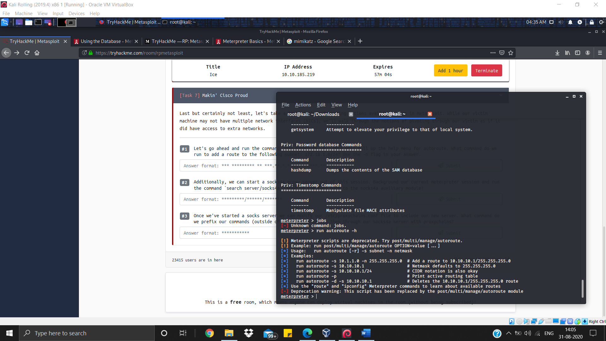

run autoroute -s 172.18.1.0 -n 255.255.255.0

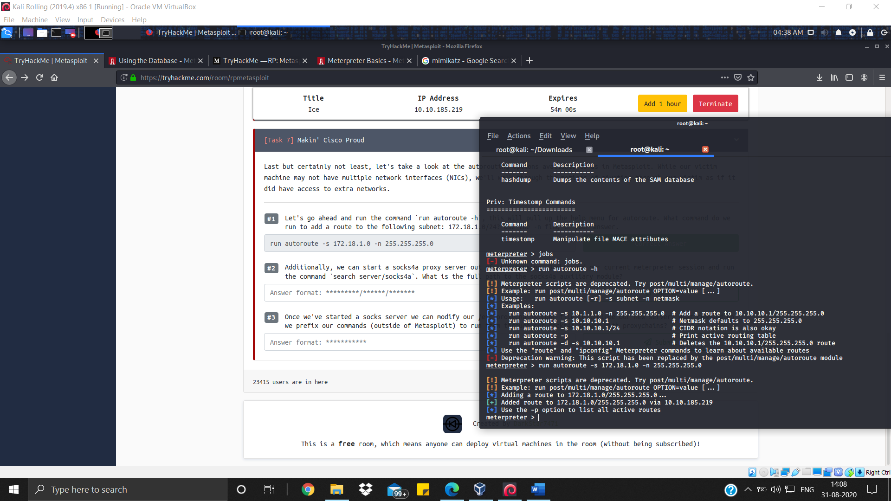

To background the meterpreter run background and then run search server/socks4a

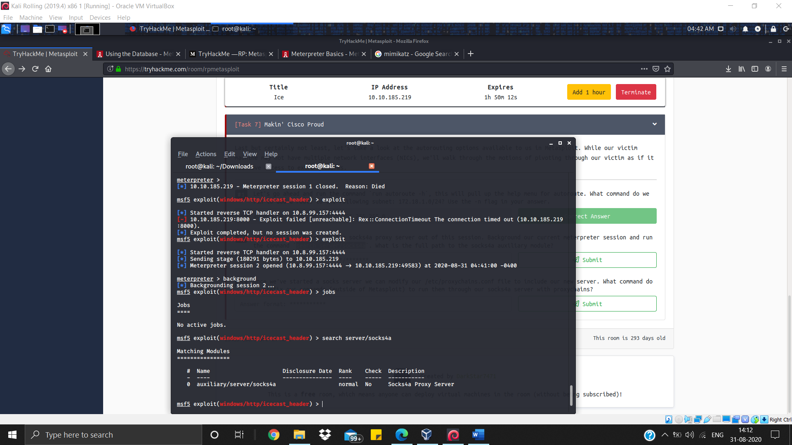

Proxychains will be used as prefix